**Team Contract**

1. **Introduction**
   1. This contract strictly governs the way in which Team 11 operates during the CSC2022 module. It will specify what is meant by formal and informal meetings, as well as the way each meeting is recorded, and by whom.
   2. This contract will also outline contingency plans in order to account for illness and technological interruptions that may hinder progress and performance on the project.
   3. An outline of permissible behaviour will be given, stating what is acceptable in terms of professionalism and equality.
   4. This contract will be signed by each member of the team in order to show that they are in agreement with what is written here, and that they are to abide by such detail at all times. Once signed, all members are bound to this contract, and will be referred to at any time deemed appropriate by the team to support any matters of conflict resolution.
2. **Formal Team Meetings**
   1. Formal team meetings will be scheduled on one day every week, excluding extended holiday periods such as Christmas and Easter. These meetings will take place in the Daysh Rack in the assigned slot as booked by the module staff.
   2. Attendance is mandatory for all formal team meetings, and any absence without full explanation will be met with suitable consequences.
   3. Suitable reasoning for any absences without explanation will include matters such as family issues or severe illness, or any similar matter as unanimously agreed by the team.
   4. If a team member is not available for the formal team meetings, acknowledgement of any absence must be made via a phone call or text message to the team leader or any team member. This can also be delivered through a social network, such as on the Team Project group on Facebook. Details of communication are outlined in section 6.
   5. Formal team meetings will be organised in the following way:
      1. A member of the team will chair the meeting.
      2. The chair will be responsible for delivering the present agenda and guiding the conversation as well as encouraging opinion throughout the group.
      3. The chair will be responsible for taking minutes during the meeting. Minutes are an effective and concise summary of the meeting and will follow the flow of ideas and contributions from the group as a whole as well as specifying individual contributions. These minutes should be approved by the remainder of the group at the beginning of the following meeting as true and accurate.
      4. The chair will be responsible for designing the future agenda for the following chair to run through at the next formal team meeting.
      5. Any member of the team can be elected as chair of each individual formal team meeting.
   6. Members should not only all contribute to a formal team meeting but also influence and encourage other members to contribute their ideas to the team.
3. **Informal Team Meetings**
   1. Informal team meetings can be called at any time and location with adequate justification within an acceptable time period by any team member.
   2. Notice of informal team meetings should be given through appropriate means of communication. These means may include via SMS or communication through the Facebook group, as outlined in section 6.
   3. The members who are necessary for each informal team meeting will be required to attend when given due notice and justification of an informal team meeting. All members should attend these meetings if required, but attendance may not always be mandatory and will be defined by the leader of the meeting and/or team leader.
   4. Informal team meetings will not follow any code of conduct and will be treated more as a way of sharing ideas, updating other members of a sub-team on their overall progression on a piece of work and update the group on any successes/failures.
   5. Informal team meetings will be lead by the organiser of the meeting. The organiser will be in charge of organisation of the meeting, including location and time, as well as the content of the meeting. An informal agenda and/or objectives may be included by the organiser of the meeting.
4. **Outside Team Meetings**
   1. The work delegated and assigned to members of the team should be treated, in terms of importance, as if the work was for any other module. Assigned work will abide by the following criteria:
      1. The work must be completed to a suitable standard in terms of quality and within the agreed time frame. Failure to complete the work within the suitable time frame will be met with suitable consequences.
      2. If support in completing a section of workload is necessary it is acceptable to ask for appropriate support from another team member.
      3. If a team member cannot complete any section of their assigned workload, they may have their workload reassigned to another suitable member of the team.
      4. If a team member is unable to complete a workload it would be deemed acceptable to change the workload between members of a team with suitable justification and compliance of not only both team members applying to swap workload but also the team leader.
   2. Members of the team can communicate with each other at any appropriate time for any means of communication and/or group work on a part of the project. Communications can take place with the use of mobile phones or use of the Facebook group, in accordance with the regulations outlined in section 6
   3. The ideas of the team and/or the details of the project stages should not be shared with any other Stage 2 Computing Science student. Any sharing of ideas with other members of other teams in Stage 2 Computing Science will be met with suitable consequences.
   4. Plagiarism will not be accepted by the team and any work containing any plagiarised resources will be restarted and met with suitable consequences. Members of the team may not pay for any resources and will be solely responsible for all work they provide to the team.
5. **Acceptable Behaviour**
   1. Racism, sexism and/or any form of discrimination should be brought to the attention of the group and will not be tolerated. These will be met with severe consequences.
   2. Any bullying and/or physical violence in the group should be brought to the attention of the team leader as well as a member of module staff.
   3. Professional behaviour must be maintained at all times when in formal meetings.
   4. All team members must allow other team members to express their ideas, and must certainly not put down others at the expense of their suggestions.
6. **Communication**
   1. During the course of the project, all members of the team must stay in constant communication. Methods of agreed communications are outlined below:
      1. Facebook group: *A dedicated Facebook group shall be established in order for all members of the team to stay in communication via a channel that is frequently used. All posts in the group shall be strictly in accordance with Internet standards, and shall only relate to the project.*
      2. Mobile phones: *Each member of the group shall share their mobile phone number, meaning each member can be in private contact with another. For example, sub teams can communicate with each other on small issues that do not require the attention of the whole team. Absences from meetings are to be notified to the team leader.*
      3. GitHub: *A GitHub repository shall be established as to allow each member of the group to share and track changes made to team documents. All changes are tracked, and no member of the team is to alter the contents of any document in the interest of the team, without first notifying the team, and tracking all changes that have been made. All members of the team must approve changes to team documents.*
7. **Contingency**
   1. Contingency plans will come into effect should the project be reasonably delayed. These contingency plans primarily cover illness of members of the team, technological interruptions, or any other instances that involve the progression of the project to possibly be delayed.
   2. Should any member of the team be unwell, or have commitments that may cause them to fall behind on a specific task, they **must** inform the team on one of the communication channels outlined in the section above.
   3. Should any member of the team feel the need to make use of the contingency measures, they will not be frowned up, mocked, nor thought disapprovingly of by any other member of the team.
   4. Contingency forms the basic principal that the team can continue progressing forward, should we temporarily lose a member of the team, or a member of said team feels their burden is too high. Contingency measures are outlined below:
      1. Communication: *This principal forms the basis of all contingency plans. All members of the team that feel they need to make use of the contingency methods must ensure they speak out. This is absolutely fundamental in being able to catch the problem in its early stages so as to not let the problem build up and it becomes an even larger issue later in the project.*
      2. Balancing of workload: *This method shall form the primary basis of contingency plans. Should one person in the team feel that they are unable to undertake their assigned item of work, they are then to immediately inform the group. This item will then be re-distributed between the team to ensure the minimal amount of disruption. The team will focus strongly on the principal of “a problem shared is a problem halved”.*
      3. Sub-team meetings: *Should a matter arise relating to one specific item, then any member of the team may seek assistance from any other member of the team in the same sub-team, or otherwise. For example, if a problem arises when it comes to implementing code, then the coding team may meet, where it is not necessary for those focussing on documentation need not attend.*
      4. Extra meetings: *If it is deemed necessary, then extra informal team meetings may be called in order to complete an assigned task before a set deadline. These meetings can be called by anyone who deems it necessary, as outlined in the section outlining this issue previously in the contract.*
8. **Repercussions**
   1. Sanctions shall be issued accordingly where deemed necessary in response to unacceptable behaviour. Sanctions and examples ranging through levels of severity are outlined below:
      1. Not contributing to team tasks: *This will be reflected in the contribution matrix. Members of the team not participating to the level of other members will be recognised as having not done so when the final submission of the task is due.*
      2. Deliberate corruption of data etc.: *Any member of the team found to have engaged in such a deliberate act of destruction will be asked to explain themselves to the group, and will have access to group files restricted due to the level of trust lost. Module leaders will be informed.*
      3. Espionage: *Any team member seen or known to be engaging in such activities will be asked to explain themselves to the group, as chaired by the team leader.*
      4. Bullying, Racism or Sexism: *Any team member found to have caused physical or emotional harm to other members of the team will be* ***immediately*** *reported to the module leaders, and recommended by the team to be excluded from future group activities.*
9. **Team Structure**
   1. The team structure shall consist of a mix between a Democratic and Hierarchical team, in that all members are given equal voicele in decision making and allowed to take responsibility for tasks. Members are guided by leading individuals through each of the developmental stages, whom are ultimately responsible for assigning all work to members and ensuring time frames are stuck to as best as possible.
   2. Leaders in themselves change between each stage, with the replacing Leader having worked on the previous stage and given the task to ensure successful completion of the current stage. This should ensure the current Leader had worked on the Specification, and has a good visualisation of the overall App in order to complete all necessary sections for the Design stage.
   3. The team has been split into three flexible sections, with bold initials indicating Leaders:

9.3.1 Documenters, to focus on Requirements:

* + **Nicholas Seaborn**
  + Samuel Emerson
  + Callum King
    1. Designers, to focus on Specification/Design:
  + **Samuel Emerson**
  + **Egle Martinkute**
  + Callum King
  + Euan Cowie
    1. Programmers, to focus on Implementation/Testing:
* **Euan Cowie**
* **Shaun Heald**
* Nathaniel Mordain
* Egle Martinkute
  1. With these non-concrete team roles:
* Nicholas Seaborn to be Team Manager, and Documentation Manager
* Samuel Emerson to be Documentation Reviewer and Content Manager
* Callum King to be Design Leader, with Egle Martinkute as Graphic Designer.
* Euan Cowie to be Head Programmer, with Nathaniel Mordain as a Java Programmer
* Shaun Heald to be Testing Leader and Quality Assurance
  1. The team will follow the Waterfall Model to ensure we have measurable and clear objectives from a solid initial idea, and can progress linearly throughout the project, although Leaders may deviate from this, to say an Evolutionary Model in implementation if desired. Within this, we will generally follow a SCRUM Team method to ensure we have a backlog of work to do, and self-organise ourselves to work more efficiently in both time and resources available.

1. **Acceptance**
   1. All team members shall sign this contract, and once signed, are bound by its terms.
   2. This document shall have the final word when it comes to issues arising in the group.
   3. Once signed, no person in the group may contest any details contained within.
   4. Should the contract need to be changed, it shall only be done so with approval of every member of the team, and is to be changed only by the documentation team, under the supervision of an independent member of a sub-team.
2. **Signed as Accepted**



*______________________________ ______________________________*



*Samuel Emerson Nicholas Seaborn*



*______________________________ ______________________________*



*Euan Cowie Shaun Heald*

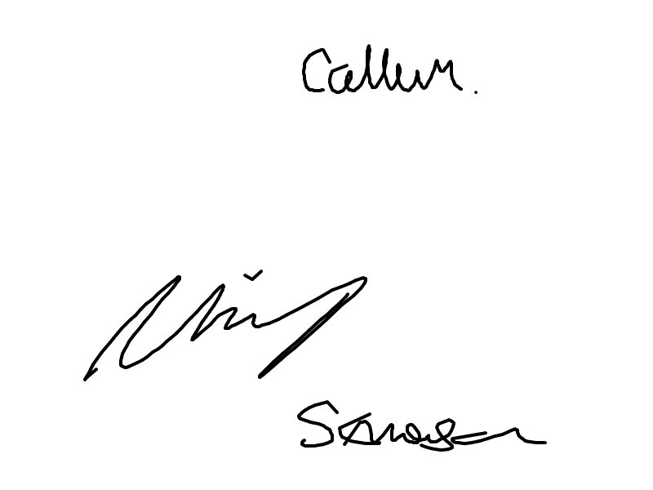



*______________________________ ______________________________*

*Nathaniel Mordain Callum King*



*______________________________*

*Egle Martinkute*